APPENDIX A
PHOTOGRAPHS TAKEN DURING JIV AT 6” PIRIGBENE-OBAMA PIPELINE AT EPEBU COMMUNITY, OGBIA L.G.A, BAYELSA STATE ON 22ND MARCH, 2024.
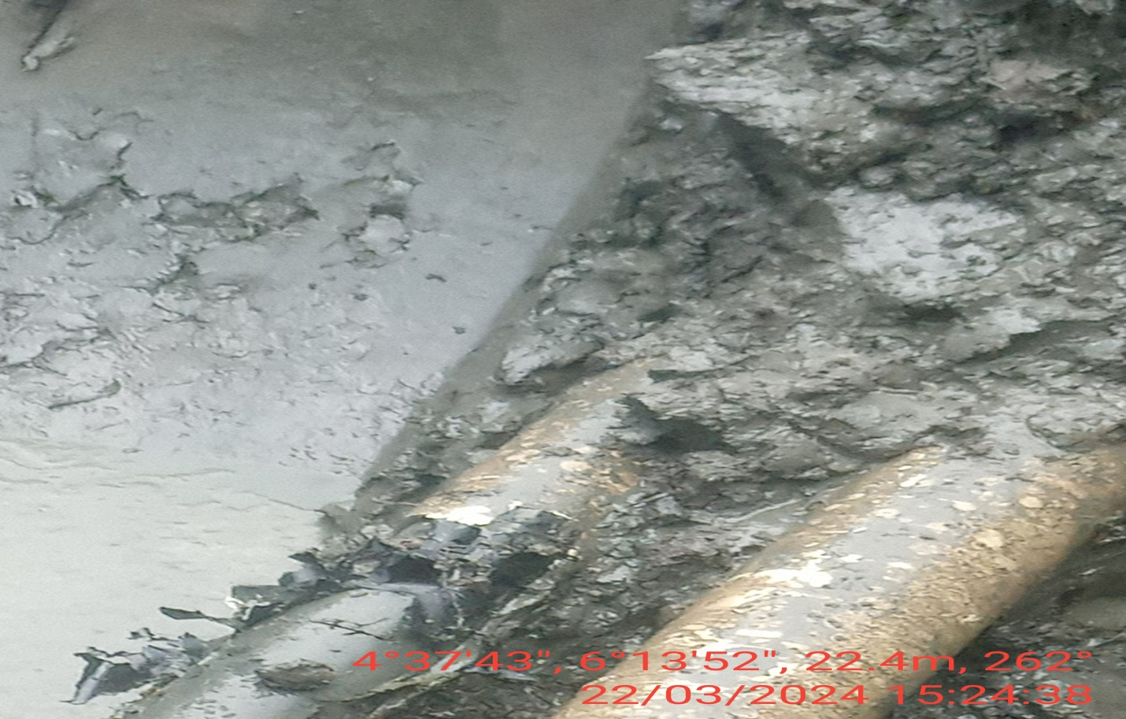
FIG. 1: ABOUT 100MM CUT MADE ON THE PIPELINE BY VANDALS.

